**Balaji K**

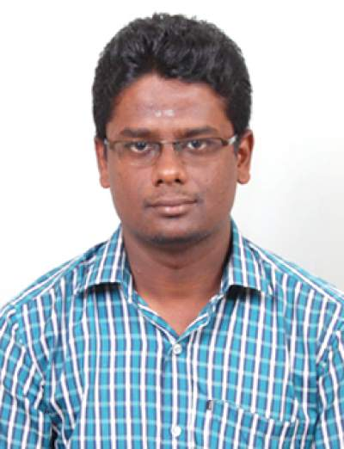0

# 

**Email:** [krishbala49@gmail.com](mailto:abishekgurumurthy@gmail.com)

**Phone:** +91-9487046716

4, Kannan Avenue Main Road, Old Perungalathur, Chennai- 63

# Experience

|  |  |
| --- | --- |
| DESIGN ENGINEER – TRAINEE (25 Months) From June 2019*Makeorbuy contracting Pvt. Ltd., Bangalore.* *(Geodesic Techniques Pvt. Ltd. Group)* | |
| Enquiries | |
| Coco Cola Manufacturing Plant, Hyderabad. | Design of roof (Area = 34000 SQM) in 3 different configurations – (i) Space frame, (ii) Truss and (iii) Primary and Secondary Beams as per IS codes. |
| Storage shed, Gambia. | Designed the curved roof of area 15000 SQM using truss as per IS 800. |
| RIL PV Manufacturing Shed, Gujarat. | Development of complex truss geometry for purlin free roof.Designed the pitched roof truss of area 21000 SQM as per Indian Codes. |
| GCC Club, Mumbai.(G+7) | Steel design – Beams, Columns and braces as per Indian Standards. |
| Data Centre, Pune. (G+3) | Design of Steel Beams, Columns and braces as per IS codes. |
| Kensri School, Bangalore. | Designed the sports complex floor and roof using Truss as per IS 800. |
| Panchshil, Pune. G+12) | Design of Steel Beams and CFT Columns. |
| M-FAR, Pune. (G+14) | Controlling Modal behaviour and story drifts under Team lead’s guidance. |
| Projects | |
| Phoenix – Equinox, Hyderabad. (B2+G+30) | Developed AutoCAD script file to automate the generation of fabrication drawings.Developed my leadership skill by heading a team of 7 detailers and delivered the fabrication drawings much before the deadline by proper planning and motivation, under pressure.Checking of fabrication drawings of beams, columns and shear walls. |
| Phoenix – 285 T6, Hyderabad. (G+17) | Connection design – Design of shear connection as per IS 800. |
| R&D | |
| Connection Program Development | Development of python program for connection for automation and optimization of design of connections. |
| Composite Beam Development | Worked as a part of Research and Development team for developing a new economical and low depth composite beam section.Studied the basis in which moment – load interaction curves are formed in SP-16, as a part of composite beam development. |
| Precast Slab system | Worked as a part of R&D team in developing precast slab for achieving formwork free floor plate system.Learnt the basics of Pre-tensioning, as a part of development. |
| Internship | |
| Chennai Metro Rail Ltd. | Studied the Structural and Architectural drawings of metro stations.  The design and detailing of beams of metro stations are studied. |

# Academic Profile

|  |  |  |  |
| --- | --- | --- | --- |
| COURSE | INSTITUTION | YEAR OF PASSING | PERCENTAGE |
| M.E. - Structural Engineering | MEPCO Sclenk Engineering College, Sivakasi. | 2019 | 89 |
| B.E. - Civil Engineering | Sri Sairam Engineering College, Chennai. | 2017 | 84.6 |
| Higher Secondary | S.R.G.D.S. Matriculation Higher Secondary School, Thiruvannamalai. | 2013 | 92.9 |
| Secondary | S.R.G.D.S. Matriculation Higher Secondary School, Thiruvannamalai. | 2011 | 94.2 |

# Accomplishment

* Completed the courses **“The comprehensive ETABS professional course (RCC and Steel)” and “Structural Steel design of Pipe racks”** in UDEMY.
* Completed the IIT madras certification course on **PYTHON**.
* Won **Best Paper award** for paper on “Thermal and acoustic performance evaluation of bricks incorporating sewage treatment plant sludge” in International Conference on Innovations in Engineering, Science and Technology 2019 (ICIEST 2019).

# Software Skills

* Analysis & Design – Etabs and Staad Pro.
* Modelling & Drafting – AutoCAD
* MS Excel
* Cad Script
* Python

# Areas of Interest

* Structural Analysis.
* Steel Structures Design.
* Automation.

# Publications

* A journal on “Development of brick as a Thermal and acoustic resistant building component” in International Journal of Engineering Research and Applications (IJERA).
* A journal on “Experimental study of removal of Fluoride in water using Bio-Material” in International Research Journal of Engineering and Technology (IRJET)

# Project Details

* **Design of Pedestrian subway using Box Culvert.**

Manual Design of pedestrian subway using Moment distribution method.

* **Experimental study of removal of Fluoride in water using Bio-Material**

Studied the side effects of presence of fluoride in drinking water and designed the low-cost fluoride filter by performing pilot studies and experimental studies.

* **Development of brick as a Thermal and Acoustic resistant building component**

Enhanced the thermal and acoustic property of bricks by incorporating waste materials. The thermal behaviour was compared with ANSYS analytical results and Acoustic behaviour was compared with ABAQUS analytical results.

# Languages

# Tamil Native Proficiency

# English Professional working proficiency

# Telugu Limited Proficiency

# References

* Haridoss B,

Design Engineer,

Geodesic techniques pvt. ltd.

Contact No.: 9750423653.

* Naveen B,

Design Engineer,

Makeorbuy Contracting pvt. ltd.

Contact No.: 8903043535.